THE PRESIDENT’S OFFICE
REGIONAL ADMINISTRATION AND LOCAL GOVERNMENT
LONGIDO DISTRICT EXAMINATION SYNDICATE
PRE-MOCK EXAMINATION
GEOGRAPHY FORM FOUR
CODE: 013
TIME: 3 HOURS MARCH, 2021
Instructions
- This paper consists of three (3) sections A, B and C with a total of ten (10) questions.
- Answer ALL questions in section A and B and two questions from section C.
- Section A carries fifteen (15) marks, section B carries fifty five (55) marks and section C carries thirty (30) marks.
- Map extract of Ilonga (sheet 265/2) is provided
- Programmable calculators, cellular phones and any unauthorized materials are not allowed in the examination room
- Write your NAME on every page of your answer booklet(s).
SECTION A (15 MARKS)
Answer all questions in the section
- For each of the items (i)-(x) choose the correct answer from among the given alternatives and write its letter beside the item number in the answer booklet provided. (10 marks)
(i)The choice of suitable site and land location for a weather station includes;
(A)permanent place for recording the data (B)more vegetation and relief (C)rain gauge, thermometer and barometer (D)fairly level ground and open space (E)flat land and thermometer
(ii)Testing of nuclear, dynamite and mining explosion are greatly associated to ---- forces.
endogenic
(A)exogenic (B)artificial (C)explosive (D)endogenic
(iii)Geography is multi-disciplinary subject because it ……
(A)is very much related to geology (B)cuts across other disciplines (C)is a tool of understanding the universe (D)involves studies of physical and human economic geography (E)deals with physical environment only
(iv)The earth`s interior is inaccessible and very hot, the knowledge about it is through ……
(A)bore hole drillings (B)evidence of the earthquake waves (C)the study of crust, mantle and core (D)continental and oceanic movement (E)oceanic floor and the core
(v)Tilting of the electricity poles and fences on slopes are works of ….
(A)weathering (B)denudation (C)steepness of the slope (D)mass wasting (E)deposition
(vi)…… soil is heavy, has minute air spaces, holds much water, is difficulty to cultivate, dries up and forms a hard surface
(A)loam (B)clay (C)silt (D)sand (E)volcanic
(vii)The best major feature of the ocean flow for fishing activities is…
(A)continental shelf (B)oceanic plain (C)oceanic deep (D)continental slope (E)oceanic island
(viii)Decline of food production and increase in droughts, floods and shortage of hydroelectric power supply are attributed to
(A)social and economic development (B)problem of climatic changes (C)impact of reduction of erosion (D)development of science and technology (E)diseases and pests control
(ix)Which of the following show the natural vegetation found in Tanzania?
(A)coniferous, Mediterranean and mountains (B) forests, tropical grassland and thickets
(C)temperature, tropical and deciduous grassland (D)savanna, equatorial grassland and tundra
(E)tundra, maritime and grassland
(x)Mr. Sonko is a tourist who visited in Northern London, unfortunately he saw semi-circular depression on the footwall of a mountain but he failed to identify that depression. Mr. Sonko can be helped to name that feature as….
(A)arête (B)col (C)cirque (D)pyramidal peak (E) roche mountonee
2. Match the items in list A with the responses in list B by writing the letter of the correct response beside the item number in the answer booklet provided. (5 marks)
LIST A | LIST B
(i)wind which blows more frequently in a particular region | A. trade winds
(ii)the amount of water vapor in the atmosphere | B. dew
(iii)there is a decrease of temperature 0.6⁰C per 100m | C. when one ascends the mountain
(iv)lines drawn having the same amount of clouds | D. relative humidity
(v)collection of small droplets of water | E. prevailing wind
 | F. isohel
 | G. humidity
 | H. when one descends the mountain
 | I. hail
 | J. isoneph
SECTION B (55 MARKS)
Answer all questions in this section.
3. Carefully study the map extract of ILONGA (sheet 265/2) provided, then answer the following questions:
(a)Calculate the area of seasonal swamp in KM².
(b)A taxi driver was moving in all weathered road from grid reference 570971 to grid reference 628030. Find the distance covered in kilometers by a taxi driver.
(c)Give the bearing and direction of Iputi grid reference 650023 to Ilonga grid reference 620987.
(d)Give three reasons which have encouraged people to establish the settlement.
(e)With evidence, suggest four (4) economic activities of the people living in the area represented by the given map.
4. Read carefully the hypothetical data presented below and then answer the questions that follow;
Cash crop production in Tanzania in `000 tones.
YEARS | Type of cash crop
YEARS | Coffee | Cotton | Tea
1990 | 200 | 100 | 300
1991 | 150 | 130 | 200
1992 | 120 | 100 | 100
(a)Represent data above using a compound bar graph
(b)How is the compound bar graph of value to you?
(c)Comment on the trend of production as observed from the graph
5. In 2008, form four students from Kibaha secondary school conducted a research about road accidents between Morogoro and Dodoma. Finally, they submitted the report to the head of school.
(a)What were the main three objectives of the research?
(b)Propose four (4) methods which might be used to collect data.
(c)Explain four problems that possibly faced them when collecting the data.
6.(a)What is the meaning of chain survey?
(b)Describe five (5) tools used in chain survey.
(c)Explain four ways in which chain survey is significant in the day to day life of human being. 7.Carefully study the photograph provided and answer the questions that follow:
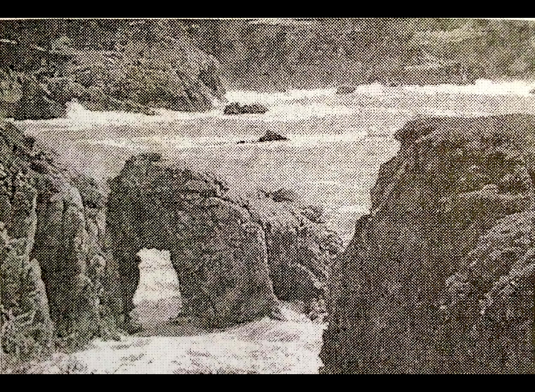
(a)Identify the type of photograph shown
(b)Name three (3) features found on the photograph
(c)How are the features named in 7(b) above formed?
(d)What are the economic importance of the features found on the photograph?
(e)Name three possible regions where the photograph might have been taken.

SECTION C (30 MARKS)
Answer two (2) questions from this section
8. Mining is an important sector in the Tanzanian economy. Some people in this sector are practicing small scale mining. Write six (6) effective measures to be taken to minimize the problem of small scale mining in Tanzania
9. (a)Using your knowledge of population studies, provide the meaning of urban growth
(b)Explain eight (8) social and economic problems that result from urban growth.
10. “The living environment in Tanzania is suffering at the expenses of man`s activities”. With the support of eight (8) points prove this statement.

